Using DegreeWorks

At the top, you’ll see three columns of information pertaining to you:
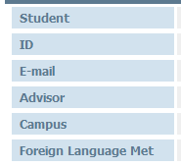
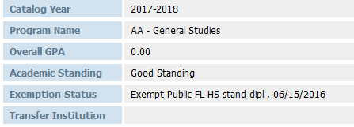
First column: Middle:

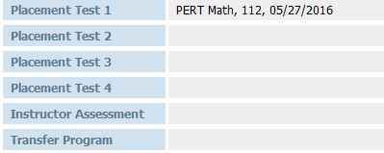
Third:

Below that you will see all of your required courses—based on your degree program. Here’s a partial view:
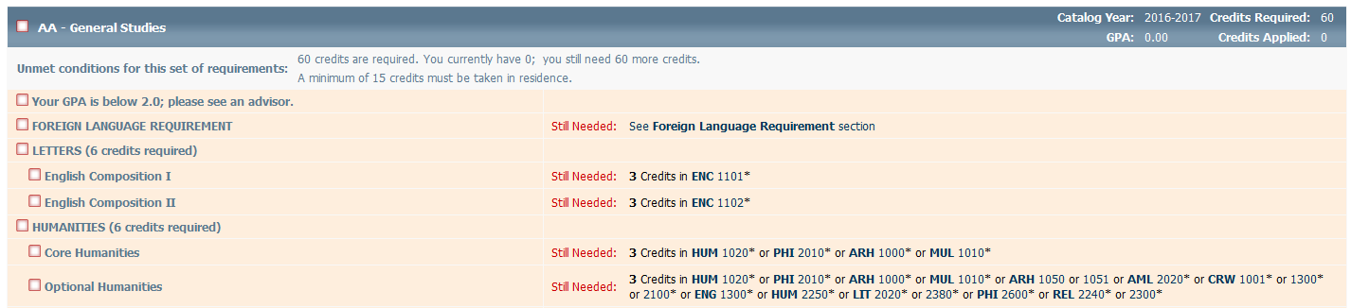

You will also see all completed and in progress/registered courses with either a checkmark or wavy dash:

When you viewing Degreeworks, you can also plan ahead and view which courses are offered in future semesters.
Select any course from the “still needed sections.” Click on the live link to view when the selected course is offered next.
Be sure to consult with your Advisor for suggested sequencing of courses.
Questions? Contact Advising Services at 305-809-3196

