Viewing Your Financial Aid Award

- Visit the student resources page on the college website https://www.cfk.edu/resources-for-students/
- Under the “MyCFK” heading, select “Student Self Service,” and log on with your user name and password

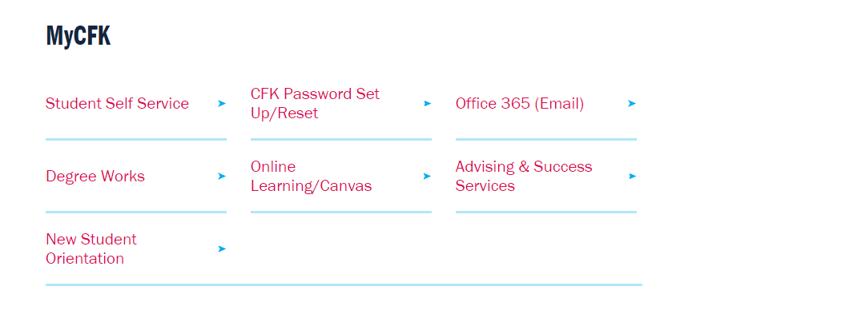
- Click on Financial Aid

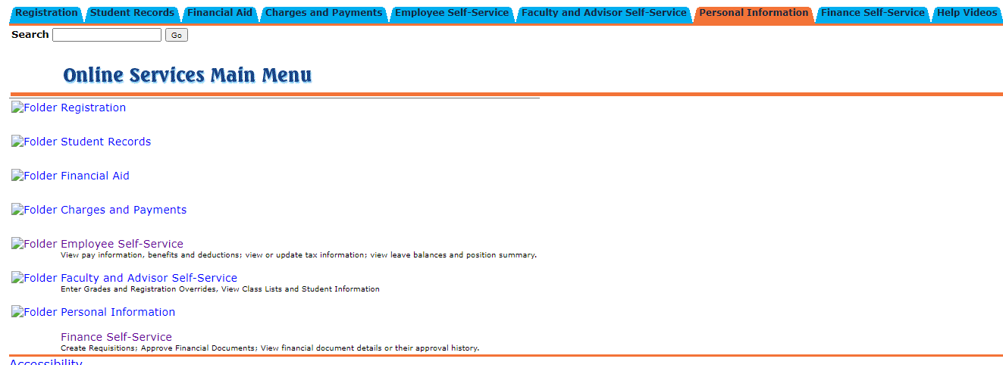

- Click on My Award Information
- Click on Award by Aid Year
- Select the award year you are receiving aid in
*2020-2021 covers Fall 2020, Spring 2021, and Summer 2021
- Click on Accept Award Offer tab. If there are still requirements, they will be listed on this page.
- From this page you can also accept your award offer.

